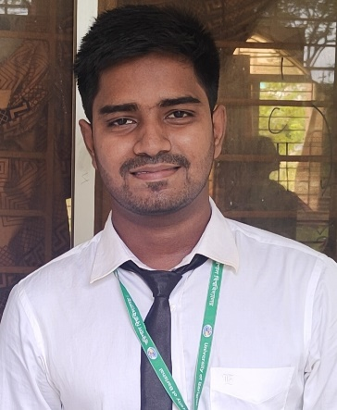

Work as a trainee for seven day field visit in Chemist Pharmaceuticals Barishal.

Work on research project about synthesis on degradable polyurea under Department of Chemistry , University of Barishal

Course: Computer fundamentals and office application

Institution: BU EDGE

**Professional Experience**

**Skill Enhancement Training**

Bachelor of Science (B. S.C )

• Concentration : Chemistry

• Institution : University of Barishal

• Session : 2018-19

• Academic Performance : CGPA 3.80 out of 4

Higher Secondary Certificate (HSC)

• Institution : Govt, Syed Hatem Ali College

• Board : Barishal

• Year of Passing : 2018

• Academic Performance : 5.00 out of 5

**Educational Qualification**

As a highly motivated and results-driven professional, I seek to leverage my skills in project management to contribute to the success and growth of a forward-thinking organization. With a strong track record of improving operational efficiency. I am committed to delivering excellence and fostering collaborative team environments. My goal is to develop and implement innovative strategies that align with the company's vision and drive sustainable business performance. I am eager to bring my expertise to a dynamic workplace where I can further refine my skills and make a meaningful impact

Md. Sakil Islam

**Career Objective**

Career Objective

* Voluntiary Work
* Public speaking
* Fund raising

**ExtraCurricular Activities**

* Bangla
* English
* Hindi

**Language**

* MS Word
* MS Excel
* MS Powerpoint
* Data Entry

 cell: 01969696404

 Email: mdsakilislamr@gmail.com

 Address: Alekanda, Barishal-8200

**Skills**

Extra curricular activities